PORTFOLIO ACTIVITY
Extending and Querying a MongoDB Collection

1.1 Modified Person schema
The Person schema describes the fields that each Person document can contain. The new field is city, with the String type. The schema now contains name, age, gender, salary and city. The name field is required; the other fields are optional unless further validation is added.

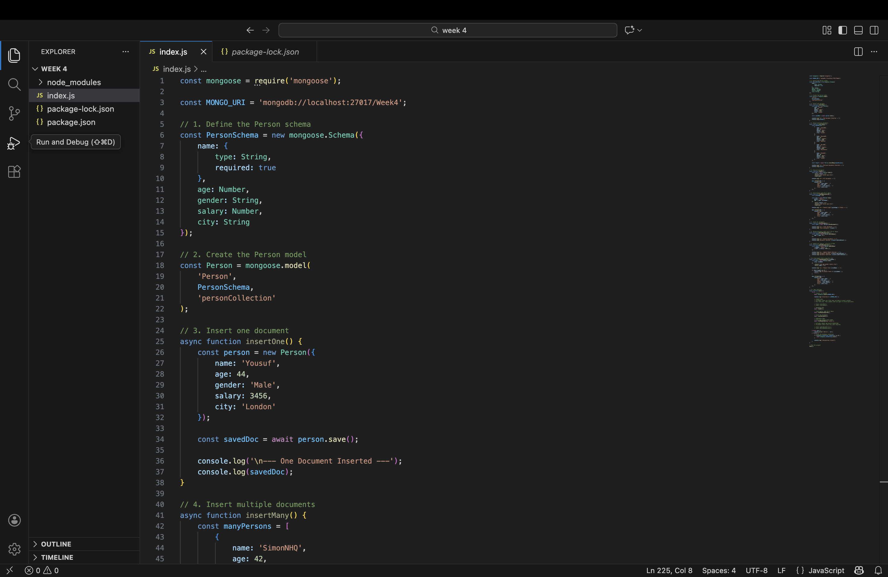

1.2 Inserting records with city values
The insertOne() function creates one Person object and saves it. The insertMany() function inserts an array of four people. In this example, the records use London, Romford and Manchester as sample city values. Use
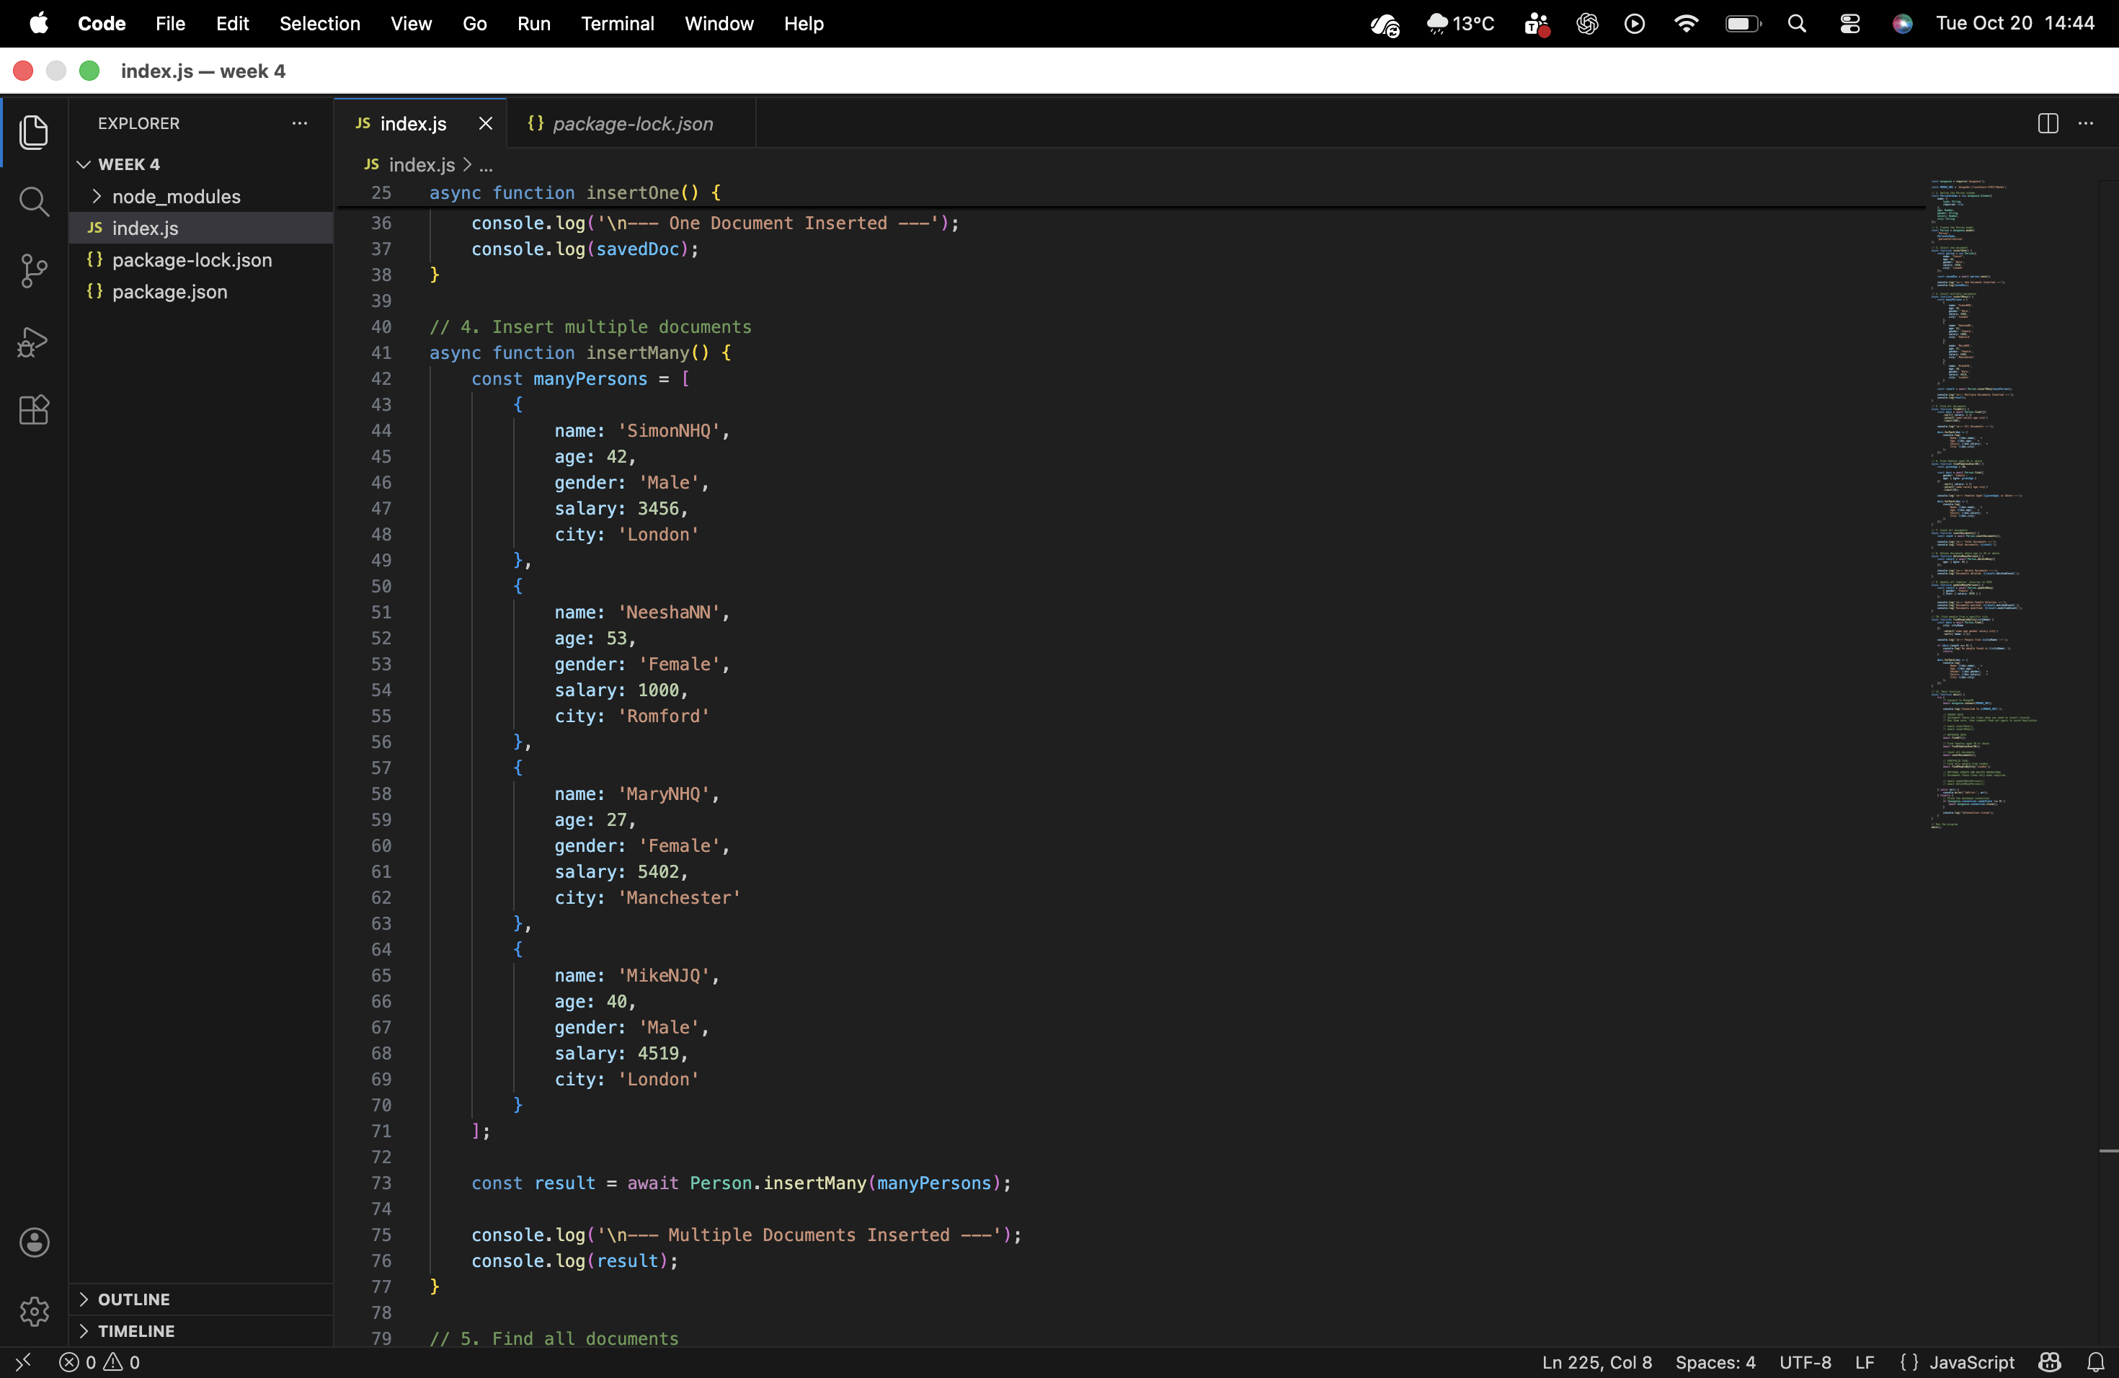

1.3 Querying records by city
The findPeopleByCity(cityName) function uses Person.find({ city: cityName }) to return only documents whose city matches the supplied value. The example call findPeopleByCity('London') retrieves people whose city field is London. The select() method limits the displayed fields, and sort() orders the results by name.
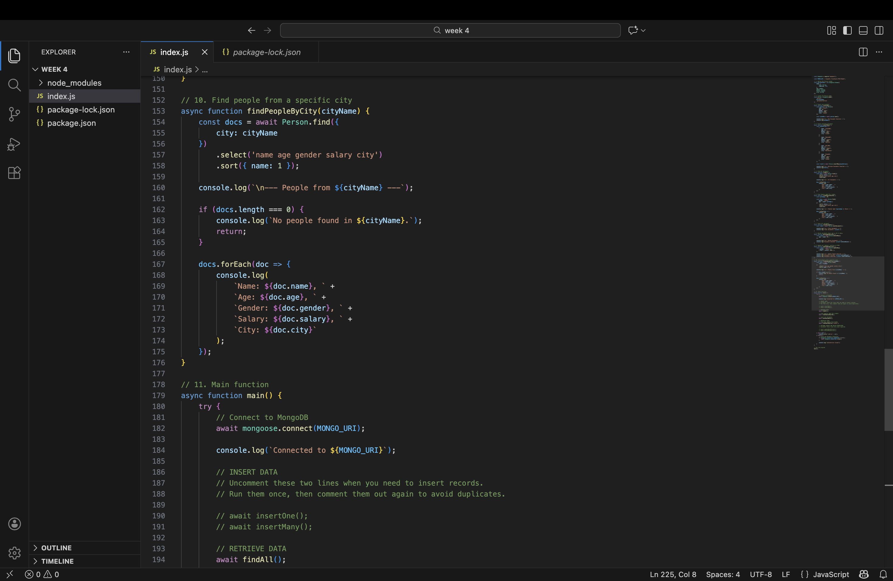

1.4 Link to the code
GitHub repository / code link: https://github.com/kaire0145-art/CN5006/blob/main/week4/index.js

Section 2: Evidence of Execution

